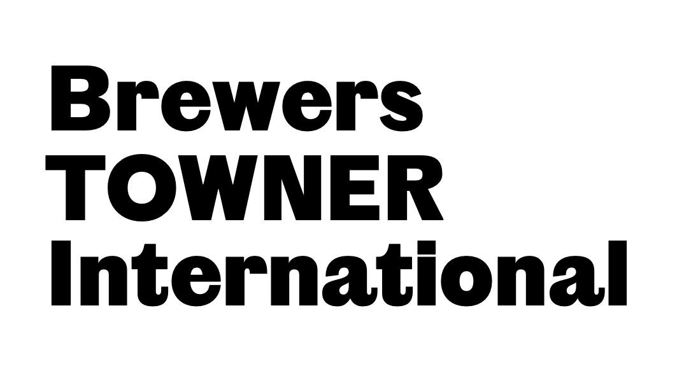

This is a document version of the online application portal. You can use this to plan your submission to the online application portal. Please note that the exact wording and layout of the form may be different in the online application portal version.

If you have any specific accessibility requirements or would like to submit your application in an alternative format to the online application portal, please email programme@townereastbourne.org.uk.

Brewers Towner International is a biennial exhibition of contemporary art by British and International artists at Towner Eastbourne.
Please read the Submission Guidelines before you begin: www.towner.gallery/BTI2022
Please have the following 3 documents ready to upload to the online application portal:
1. CV - please include a brief artist bio.
2. Submission with details of your artwork(s) including: title, date, dimensions, medium, description and images.
3. Portfolio with examples of past projects.
Application deadline: 31 January 2022
If you have any further questions, please email programme@townereastbourne.org.uk

- What is your first name? *required

- What is your last name? *required

- Are you applying as a solo artist or on behalf of a collective? *required
[ ] solo artist
[ ] collective

- If applying on behalf of a collective, please provide details of your collective, including the names of each member:

- What is the best email address for us to use with regard to your application? *required

- What is the best phone number for us to use with regard to your application? *required

- Please provide us with the best postal address to contact you on. *required
First line of address:
Second line of address (if needed):
Town:
County:
Postcode:
Country:

- Please upload your CV including a brief artist bio *required
The portal can only accept PDF or Word documents - max. file size 10MB

- Please upload your Submission with details of your artwork, including title, medium, description, and images *required
The portal can only accept PDF or Word documents - max. file size 10MB

- Please upload a Portfolio with examples of previous projects *required
The portal can only accept PDF or Word documents - max. file size 10MB

- – 17. The application portal will now ask you to complete an Equal Opportunities Monitoring Information.

Note: Collectives are not expected to fill in this section.

18. Is there any other information you would like to add?

Declaration:

I agree to the conditions of entry to Brewers Towner International (see below) and declare that I am eligible to enter.

I declare that I am aged 18 years or over. All works submitted have been completed within the past 2 years and are available for the entire exhibition period. If a work is sold during the exhibition period, 35% commission is payable to Towner. If selected, images of my work may be used for press and marketing purposes, and visitors to the exhibition have my permission to include my work(s) in their photographs.

[ ] I Agree

