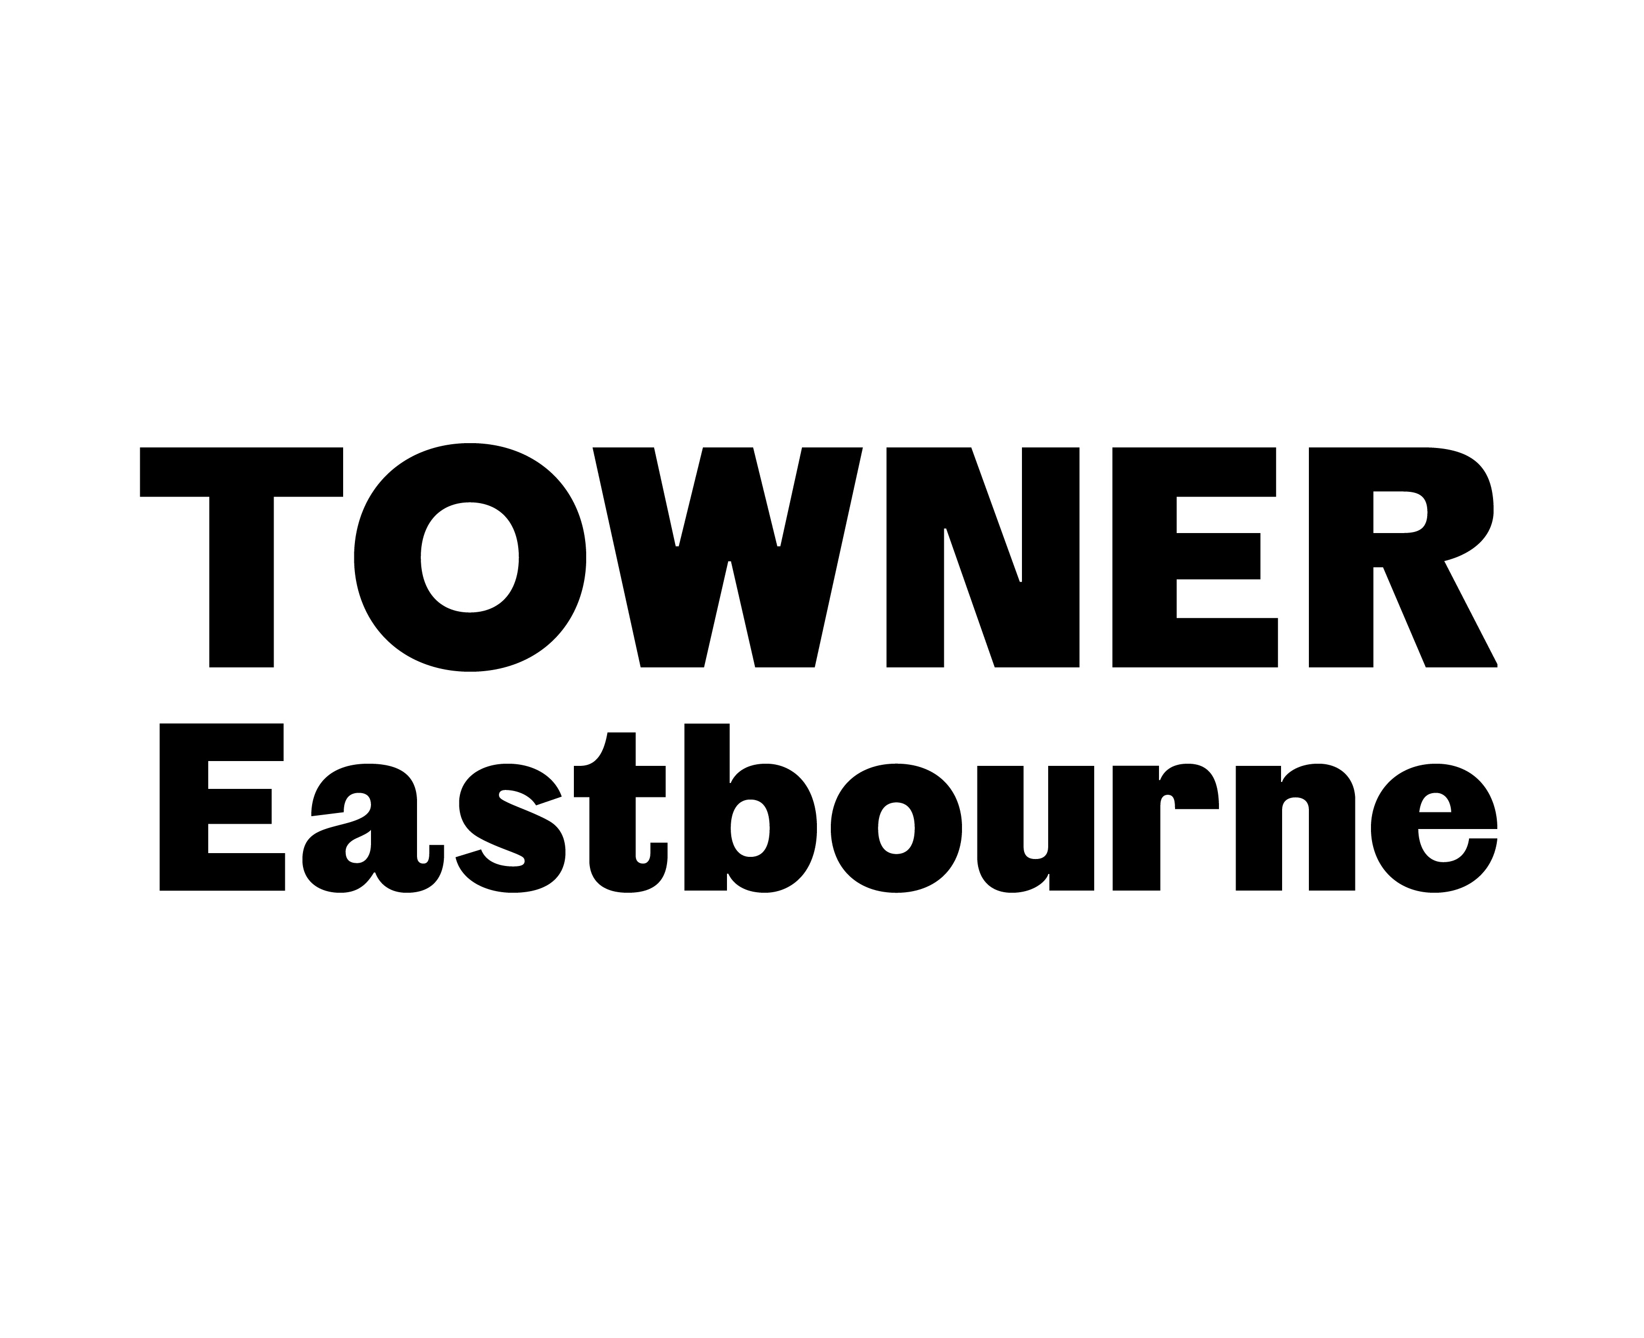
Brewers Towner International Submission Guidelines

Towner Eastbourne welcomes submissions from British and International artists to Brewers Towner International through the online entry form here:

https://townergallery.typeform.com/BTI2020

Submissions are free and the deadline is 5pm GMT on Monday 31 January 2022

Conditions of entry

- You must be over the age of 18 to enter.
- All works submitted must have been completed in the last 2 years (after 2019).
- All works submitted must be available for the entire exhibition period: October 2022 through to January 2023.
- Transport and installation dates will be confirmed with the exhibiting artists.
- If selected, images of your artwork may be used for press and marketing purposes, and visitors to the exhibition will have permission to include the work(s) in their photographs.
- If works are sold during the exhibition period, 35% commission is payable to Towner.
- We are not able to consider submissions from artists who previously exhibited in Towner International 2020. This is to ensure that Brewers Towner International can include the widest range of artists possible.

What will I need to complete the online entry form?

You will be asked to enter full contact details and to upload 3 x PDF/Word documents:

- CV please include a brief artist bio and exhibition history.
- Submission with details of your artwork(s) including: title, date, dimensions, medium, description, images and image credits. Please note that you can submit multiple works within this document.
- Portfolio with examples of past works/projects.

I create work as part of a team or collective. Can we enter work under our collective name?
Yes. Please include all names of artists with your submission and one point of contact.

How many artworks can I submit?
There is no limit on the number of artworks you can submit.

Can I enter diptychs/triptychs as one work?
Yes. Please ensure the primary image in your Submission document shows the work in its entirety.

How many images can I submit?
You can include as many images as you feel necessary in your Submission and Portfolio documents.

Are there any restrictions on the file format?

We can only accept PDF or Word documents; other file formats are not supported. The recommended file limit is 10MB per file.

How can I submit moving-image, performance and sound works?
If submitting moving-image, performance or sound works please include hyperlinks to content in your Submission document, with passwords if required.

My work needs to be installed in a specific way, can the gallery accommodate this?
If there are specific installation requirements for your work then please include these in your Submission document. Installation/lighting requirements must be supplied at this time if integral to the work.

If you are submitting installation, site-specific or off-site work.
Please supply as much information as possible in the Submission document. If selected, further discussions with the Curator will be required.

Does my work need to be for sale?
No.

Will I receive an email to acknowledge my submission?

No, your submission is acknowledged on the final page of the online form.

When will I know if I have been successful?
All artists will be notified by email on Monday 11 April 2022.

Can I receive feedback if I’m not successful?

Due to the large number of entries, it is not possible to provide personalised feedback for entrants.

What will happen to my personal information once submitted?

Our Privacy Policy (https://townereastbourne.org.uk/about/privacy-policy) outlines how we use your personal data lawfully, fairly and transparently. We keep your data safe on a secure server that is routinely monitored and your information is accessible only to appropriately trained staff. We may use this information to report to funders and/or internal evaluation only. We will never share your personal information with third parties or our judges.

If successful, what support will be in place for exhibiting artists?

- Artist Fee of £350
- Reasonable costs of transporting artwork to/from Towner.
- Experienced technical support provided for install and de-install of artworks.
- Reasonable costs of travel and accommodation to attend the exhibition opening.
- Professional documentation of the exhibition will be shared with all exhibiting artists.
Key dates to remember

- Submission deadline: 5pm GMT on Monday 31 January 2022
- All artists will be notified by email on or before Monday 11 April 2022.
- Exhibition dates: October 2022 to end of January 2023
If you cannot find an answer to your query above, and/or if you have any specific accessibility requirements or would like to submit your application in an alternative format please email:

programme@townereastbourne.org.uk

Please be aware that we anticipate a high volume of submissions, but we aim to respond to enquiries within one week

To receive the latest news about Brewers Towner International and other artist opportunities from Towner, please join our mailing list

Follow us on Instagram, Facebook & Twitter

http://townereastbourne.org.uk

